LABWORK – 5

Repeat loop in R

# ‘repeat’ executes the same code over and over until we tell it to stop
- > repeat {  + message ("Hey Beu, HAppy day!")  + }  # infinite loop | 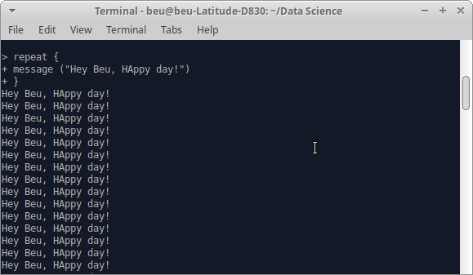
- > mySentinel <- 1  > repeat {  + print(mySentinel)  + mySentinel <- mySentinel + 1  + }  # infinite loop starts from 1 | 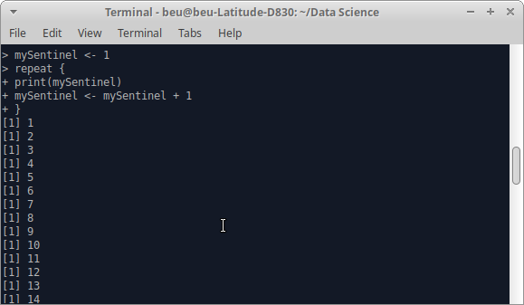
- > x <- 1  > repeat {  + print(x)  + x = x-1  + if (x == -3) {  + break }} # breaking out the infinite loop by including a break statement | [1] 1  [1] 0  [1] -1  [1] -2
- > myVector <- c ("hi", "hello")  > n <- 0  > repeat {  + print(myVector)  + n = n+1  + if (n > 5) {  + break  + }  + } | [1] "hi" "hello"  [1] "hi" "hello"  [1] "hi" "hello"  [1] "hi" "hello"  [1] "hi" "hello"  [1] "hi" "hello"
- > repeat {  + message ("happy day!")  + action <- sample (  + c (  + "Write R assignment",  + "Do JAVA assignment",  + "Go and SLEEP"  + ),  + 1  + )  + message("you should ",action)  + if (action =="Go and SLEEP")  + break  + } | happy day!  you should Write R assignment  happy day!  you should Do JAVA assignment  happy day!  you should Go and SLEEP
- > repeat {  + message ("happy day!")  + action <- sample (  + c ( "Write R assignment",  + "Do JAVA assignment",  + "Go and SLEEP"  + ), 1 )  + if (action =="Go and SLEEP")  +{ message ("skip! its time to study")  + next }  + message("you should ",action)+} | happy day!  you should Do JAVA assignment  happy day!  you should Write R assignment  happy day!  skip! its time to study  happy day!  you should Do JAVA assignment  happy day!  you should Do JAVA assignment  happy day!  skip! its time to study  happy day!  .  .

While loop in R
- > while (TRUE) {  + print("Infinite loop!")  + }  # its an infinite while loop | [1] "Infinite loop!"  [1] "Infinite loop!"  [1] "Infinite loop!"  [1] "Infinite loop!"  [1] "Infinite loop!"  [1] "Infinite loop!"  [1] "Infinite loop!"  [1] "Infinite loop!"  [1] "Infinite loop!"  .  .
- > mySentinel <- 1  > while (TRUE) {  + print(mySentinel)  + mySentinel <- mySentinel + 1  + }  # infinite loop starts from 1 | [1] 1  [1] 2  [1] 3  [1] 4  [1] 5  [1] 6  [1] 7  [1] 8  [1] 9  [1] 10  [1] 11  [1] 12  .  .
- > x <- 1  > while (TRUE) {  + print (x)  + x = x-1  + if (x == -5) {  + break }} # breaking out the infinite while loop by including a break statement | [1] 1  [1] 0  [1] -1  [1] -2  [1] -3  [1] -4
- > myVector <-c("While”,“Loop")  > n <- 0  > while (TRUE) {  + print(myVector)  + n = n+1  + if (n > 5) {  + break  + }  + } | [1] "While”,“Loop"  [1] "While”,“Loop"  [1] "While”,“Loop"  [1] "While”,“Loop"  [1] "While”,“Loop"  [1] "While”,“Loop"
- > myNum <- 0  > while (myNum < 10) {  + print (myNum)  + myNum = myNum + 1  + } | [1] 0  [1] 1  [1] 2  [1] 3  [1] 4  [1] 5  [1] 6  [1] 7  [1] 8  [1] 9
- > action <- sample (  + c (  + "Write R assignment",  + "Do JAVA assignment",  + "Go and SLEEP"),1)  > while (action != "Go and SLEEP") {  + message ("Hard Day!")  + action <- sample (  + c (  + "Write R assignment",  + "Do JAVA assignment",  + "Go and SLEEP"),1)  + message ("",action) } | Hard Day!  Do JAVA assignment  Hard Day!  Write R assignment  Hard Day!  Do JAVA assignment  Hard Day!  Go and SLEEP

For loop in R

# for loop is to be used when we know exactly how many times we want the code to repeat
- > for (i in 1:5)  + message("hi")  # iterates for 5 times | hi  hi  hi  hi  hi
- > for (i in 1:5)  + print(i) | [1] 1  [1] 2  [1] 3  [1] 4  [1] 5
- > for (i in 1:5) {  + mySquare <- i^2  + print(mySquare)  + } | [1] 1  [1] 4  [1] 9  [1] 16  [1] 25
- > for (month in month.name) {  + message(month)  + } | January  February  March  April  May  June  July  August  September  October  November  December
- > for (myVector in c ("Data Science", "Java", "Cryptography")) {  + message ("I like ", myVector)  + } | I like Data Science  I like Java  I like Cryptography
- > myList <- list (  + "hi, my name is beu",  + pi,  + LETTERS[1:10]  + )  > myList  [[1]]  [1] "hi, my name is beu"  [[2]]  [1] 3.141593  [[3]]  [1] "A" "B" "C" "D" "E" "F" "G" "H" "I" "J"  > for (i in myList) {  + print (i)  + } | [1] "hi, my name is beu"  [1] 3.141593  [1] "A" "B" "C" "D" "E" "F" "G" "H" "I" "J"

Loop Control Statements

# Loop-control statements are part of control statements in R programming that are used to change the execution of a loop from its normal execution sequence.
- > myVector <- c (1:10)  > myVector  [1] 1 2 3 4 5 6 7 8 9 10  > for (i in myVector) {  + if (i == 7) {  + break }  + print(i)  + } # break statement | [1] 1  [1] 2  [1] 3  [1] 4  [1] 5  [1] 6
- > x <- 1  > repeat {  + print(x)  + x = x-1  + if (x == -3) {  + break }} # breaking out the infinite loop by including a break statement | [1] 1  [1] 0  [1] -1  [1] -2
- > x <- 1  > while (TRUE) {  + print (x)  + x = x-1  + if (x == -5) {  + break }} # breaking out the infinite while loop by including a break statement | [1] 1  [1] 0  [1] -1  [1] -2  [1] -3  [1] -4
- > myVector <- c (1:10)  > myVector  [1] 1 2 3 4 5 6 7 8 9 10  > for (i in myVector) {  + if (i == 7) {  + next  + }  + print(i)  + }  # next statement | [1] 1  [1] 2  [1] 3  [1] 4  [1] 5  [1] 6  [1] 8  [1] 9  [1] 10
- x <- 1  repeat {  print(x)  x = x-1  if (x == -3) {  next }} # Skipping out the value ‘-3’ from the infinite loop by including a next statement | [1] 1  [1] 0  [1] -1  [1] -2  [1] -4  [1] -5  [1] -6  .  .
- > x <- 1  > while (TRUE) {  + print (x)  + x = x+1  + if (x == 2) {  + next }} # Skipping out the value ‘2’ from the infinite loop by including a next statement | [1] 1  [1] 3  [1] 4  [1] 5  [1] 6  [1] 7  [1] 8  .  .

